Adam Pedro
COMM 311
Prof. Serafin
10/18/2020

Election Guide 2020 : Gen-Z

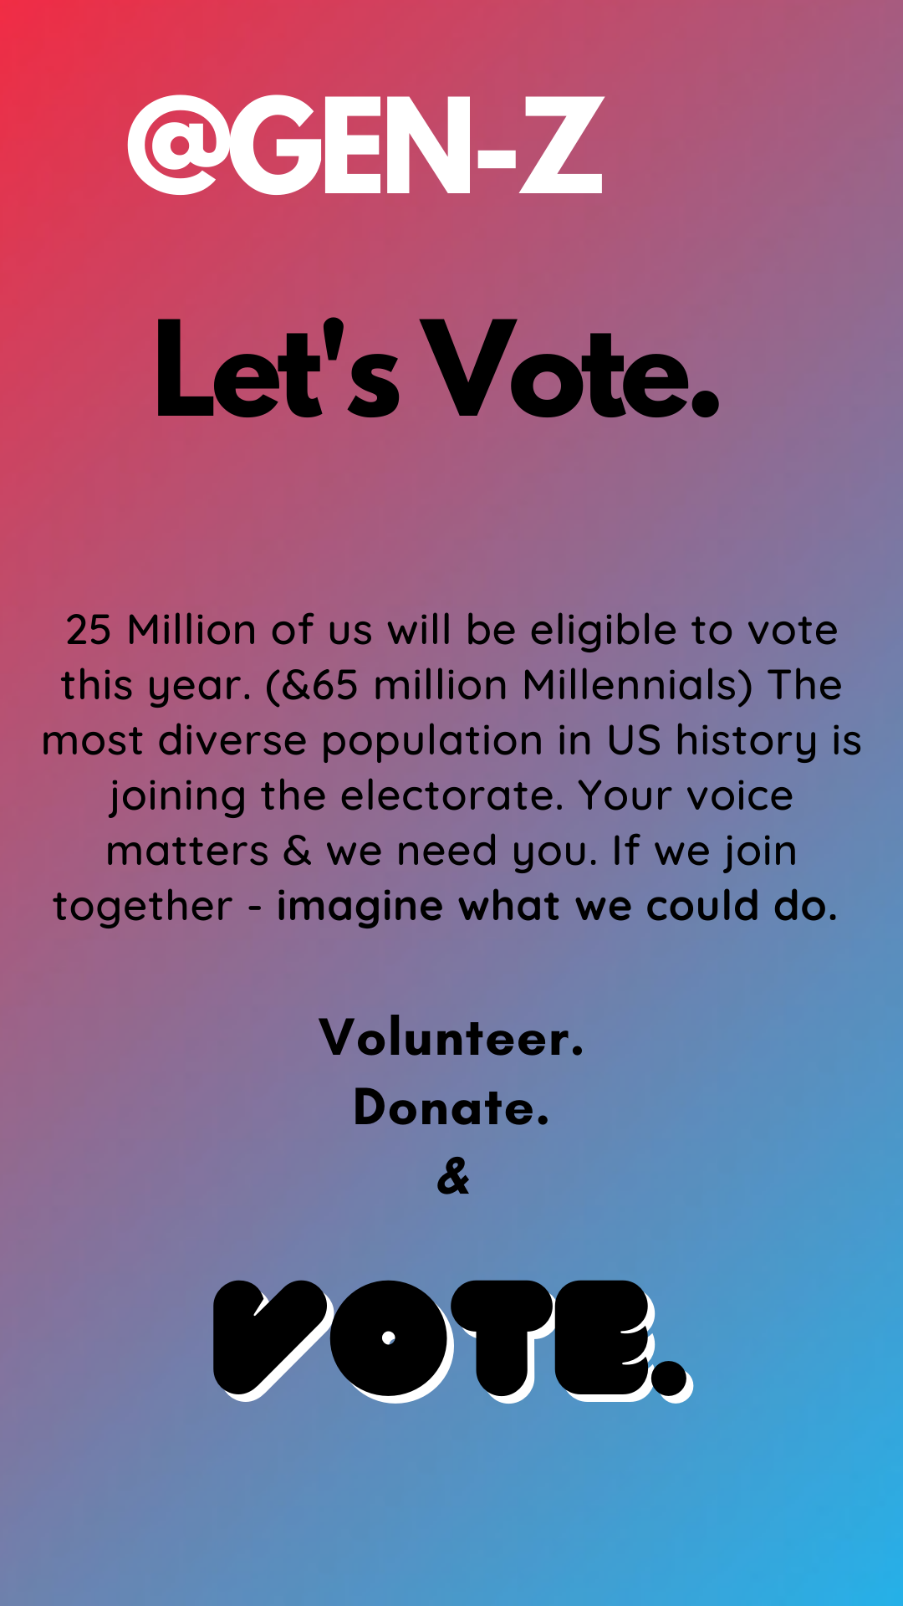

- Introduction
Generation Z is entering the electoral field and politics may never be the same. Gen-Z is the most racially, ethnically, & socially diverse generation in US History. Over 20 million of us will be eligible to vote this november. Plus, even if we’re not yet eligible, Gen-Zers are taking to social media to advocate, they’re volunteering their time & their dollars. This election is a critical moment in our political story & Gen-Z has a big stake in this election. The following guide is meant to aid you in your voting or activism. It speaks to issues that are a top priority for Gen-Z & frankly issues that everyone should be bringing to the ballot box (or mail box.) Gone are the days of voters who were rich, white, men - today in America our voting electorate is diverse, energized, and ready to speak life into a new government. Imagine if we all joined together in solidarity & a unified message, Gen-Z & the rest. Imagine what we could do...

- Candidates
  - National
The 2020 General Election, Donald Trump / Mike Pence vs. Joe Biden / Kamala Harris, is a critical race for gen-z voters. While these candidates have a particular platform, they’re also setting the platform for the two major political parties. And that is something that voters must be very much aware of if they’re voting with certain issues in mind as it’ll help decide their down ballot races. Although I won’t be discussing the 3rd party candidates in depth, I do want to mention that in the next few election cycles, Gen-Z may decide that other 3rd parties may be more in line with their issue priorities. We’ve lived through this major polarization and I’ve heard from many who are not too keen on either party, so it’ll be interesting to see how Gen-Z moves the party environment in the US. In regards to the DT/MP vs. JB/KH I’d like to bring up a few of the main Gen-Z issues - and rate them by color, and speak to how these candidates address them in more detail.
Key: +/- candidate name will be highlighted, * = leans +/- (may be missing some key policy aspects that may impact your support)

Climate Change:
Trump: Yes, Trump has said before that “climate change is a hoax,” but we need to focus on what this Administration has done - and will continue to do. The DT/MP platform is one that continues to build an America that is run on gas, oil, and fossil fuels. They’ve expanded our manufacturer of coal & offshore drilling. And they’ve opened our wildlife refuges for gas extraction & approved pipelines which impact our Native American populations. While they’re running on “energy & environment,” we should be very much aware of what they actually mean. Energy = fossil fuels & Environment = $$$ over planet. Sure they say they want “clean water, clean air” but only if it won’t impact the ability to produce more fossil fuel profit. Don’t be fooled, the DT/MP platform is one that will keep us right on track to climate catastrophe. Not that they care, they’ll be six feet under while Gen-Z Americans, POC, and low income Americans be damned - we will be living through that catastrophe (and some already are.)
*Biden: Biden/Harris will work towards a clean energy future and create a new green economy in the process. Their plan will impact issues of housing, transportation, & infrastructure to build the US into a strong leader in a new green world. They use the Green New Deal as a “crucial framework,” and many Gen-Z voters may be disappointed that Biden is not a GND supporter or making it a part of their platform. Also another point I should mention is Biden will not ban fracking, which does alienate some of the Gen-Z base. But if we look at the alternative, there really is only one option if you’re voting as a climate change voter.

Social Justice:
Trump:If you’re looking for a platform that will end police brutality, that will “defund” or reform our police state, or one that will work to end decades of systemic racism President Trump is not your candidate. Normally you’d hope to see both parties fighting to end these problems, even if they differed on how to go about that, but these definitely aren’t normal times. While we could discuss at length the President’s inability to denounce white supremacy or even his inherently racist world views, I’d like to just mention where he stands on these issues. With regards to BLM, our police brutality system, or our criminal injustice system - Trump is ready to add more fuel to the fire. Part of a Trump vote means increasing the police force in the US, destroying any notion of police brutality, systemic racism or white privilege, and continuing to institute “law & order.” A vote for Trump is a vote against advancing social justice or racial equity.
Biden: A vote for Biden is a vote for a platform that will invest in POC & build towards a racially equitable America. That means investing in Black & Brown business, creating more affordable housing, and changing our police force to incorporate more community based approaches. While a vote for Biden/Harris, doesn’t necessarily mean Defunding the Police or Abolishing the Prison System, it’ll hopefully mean moving towards that. It also means changing our education & healthcare systems to include POC. Which includes more diverse teacher forces & providing health insurance to marginalized communities.

Immigration
Trump: Yes, he campaigned on a racist border wall, on a “Muslim ban”, on “illegals” destroying our country - but the past four years of implemented policy & the possibilities of the next four, should worry all of us. The DT/MP platform is one that destroys DACA & DAPA, that ends immigration as we know it - moving us to a solely merit based system, and treats anyone who dares dream of an “American Dream” as a criminal & prisoner. They may speak about wanting to end “illegal” immigration, but once again - don’t be fooled. If we allow this administration to continue, they will kill that American Dream once and for all. If you’re in this country because of immigration - then this is personal. Gen-Z voters, think about your fellow Gen-Z Americans who are being detained, neglected & abused at the border in cages while our “leaders” view them as the evil ones. We have the capacity to remove this administration from power and send a clear signal that Gen-Z will not tolerate this ever again.
*Biden: Biden/Harris differs from Trump/Pence in that their platform will greatly alter our immigration system to allow for asylum & broader immigration. They’ll also invest in Central America which they believe would impact that root of some of the crises’ at the border. They’ll end the current administration’s cruel immigration border practices & modernize the American Immigration system. It should be mentioned that Biden will not abolish or defund ICE.

  - State (Massachusetts)

Senate:
Massachusetts’ Senate race is between the Dem. Incumbent: Sen. Ed Markey & Rep. Challenger Kevin O’Connor. Markey is a career politician who is running to keep his Senate seat, but his platform has shifted to a point that he is a clear choice for Gen-Z. While many oppose his incumbent position, that shouldn’t scare voters away from him. He is a progressive candidate who has proven what he can do as a legislator. He’s gained national attention - especially after his primary race against the Kennedy dynasty. Markey is a co-author of the Green New Deal, he’ll be a strong fighter for a climate agenda. He’ll fight for racial justice, for healthcare reform, education, disability rights & LGBTQ+ progress. *O’Connor is against Defunding the police, against the Green New Deal (or any substantive climate change agenda, although he does believe it’s real), against government healthcare. He is for “strong borders,” tax reform, government & election reform, and a strong foreign policy.

House of Representatives:
Congressional District: MA 4. Running for the Congressional Seat is Democrat *Jake Auchincloss & Republican *Julie Hall. Auchincloss is running on healthcare reform, education, reproductive justice, gun reform, and foreign policy. His opponent Julie Hall is running on a platform dedicated to working families, healthcare affordability, small business, seniors, education, and immigration. This race is really between two candidates that lean Democrat/Republican. They’re both trying to gain their party loyal voters while not upsetting independent voters. They both will fight for some of the Gen-Z issues, while neglecting to take any majorly polar stances in either direction, both are moderate candidates.
  - Local (Seekonk/Bristol County)
Bristol County Register of Probate race is between Democrat Thomas Hoye & Independent Melanie Layden. This particular race is an important position within the Family Court & Probate. Their power will impact issues of parental abuse & custody, divorce, adoption, and other family matters as well as wills, trusts, and guardianship. Hoye is an interim Register who may win the permanent seat, he is a former mayor. His work prior to COVID-19 to bring registry and records virtual, made a huge impact during this crisis. Layden has been a local attorney for 25 years, which she is pushing as a big advantage of working in the system.
- Conclusion
The 2020 election may be one of the first times you’re voting & what an election it is. On a national level, we’re given a choice between two platforms that historically have never been more different. And while that race is incredibly important, the down ballot races will perhaps affect your daily life even more. Plus it’s exciting to be a part of some of these candidate’s rise into politics. All across the country we’re seeing a massive surge of young progressives, POC, women, and queer candidates standing up and running for office. And behind them are you & me. And for every one of them who wins, we win. This election you get to decide the kind of government that will serve you. Ask yourself - what should that government be about? How should it serve you? And also equally important, what should it look like? America today, let's face it - it’s a mess. But then again when hasn’t it been? Do we give up? Or is to give up to spit in the face of every American who came before us who broke the mold of what America could be? We’ve heard it thousands of times and it never loses its appeal - We The People, in order to form a more perfect union...do ordain and establish...the United States of America. What is perhaps hidden in those lines is that every election - “We” change, we’re always forming a more perfect union, and we’re always creating a new America. If you’ve ever doubted the power of your vote, remember the line “I won’t forget the ones who died who gave that right to me.” The ones who gave you that right were not free, rich, white men; that’s the myth. It was people like you & me, who spoke. You, no matter how young or old, how black/white/brown, how straight or queer, how rich or poor, how rural or urban, how abled, how uneducated or educated, how Christian/Muslim/Jewish/Atheist or other, how ever long you or your ancestors have inhabited this ground; you are powerful. And through your vote - your voice, that little act of checking a box, means that you are capable of radical change, or speaking volumes, of breathing new life and you are the very definition of America. If we could travel back to 1787, to that room full of free, rich, white men - and told them how it all turned out…

- BALLOT QUESTIONS
Question 1: Yes: Update Right to Repair Law, allows independent car mechanics & car owners to have access to vehicle data. It’s passage would mean automobile manufacturers would not have a monopoly on repairs. No: Would keep vehicle data in the hands of automakers. Opposition to question 1 is largely funded by the big automakers in an effort to tighten the dealership mechanic dominance. They’re opposition is using a series of ads to convince the public that allowing independent shops & vehicle owners access to this data would create major privacy concerns. If you’re for small business auto mechanics & right to data - vote yes on question 1.
Question 2: Yes: Makes Ranked Choice Voting Massachusetts law - which would impact Local, State, & Congressional Races. Up to now, only Maine has such a voting policy. No: Would keep elections as they are, plurality voting. Before voting on question 2, look into RCV in other countries & certain jurisdictions here in Massachusetts. This could be a major signal to other states/federal gov to follow so it’ll be interesting to see if Massachusetts decides to say yes to RCV.

